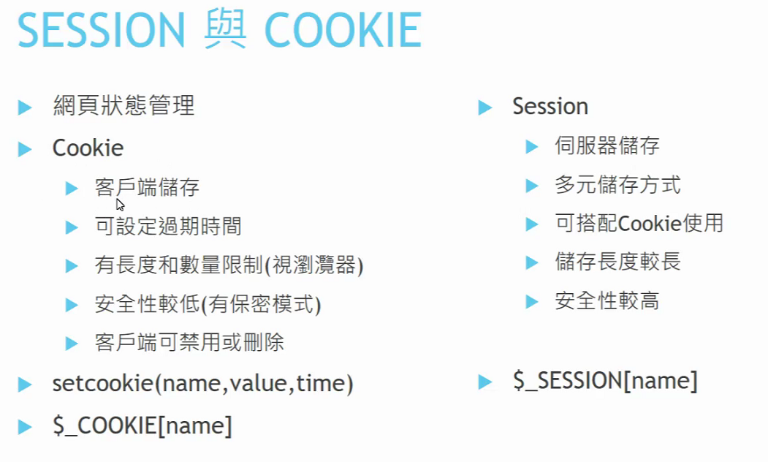

<https://git-scm.com/download/win>

VS 終端機 ctrl +shift+`

PS C:\myweb\login> git status

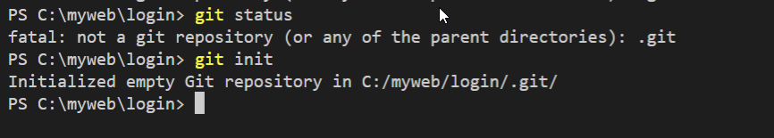

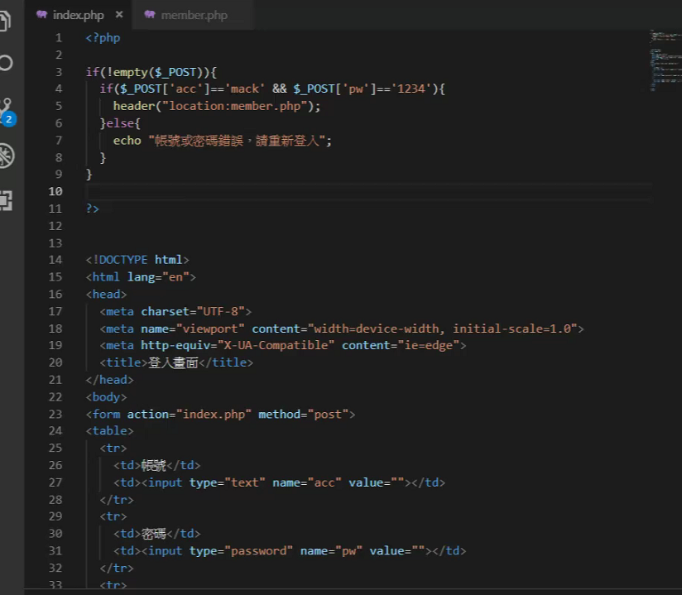

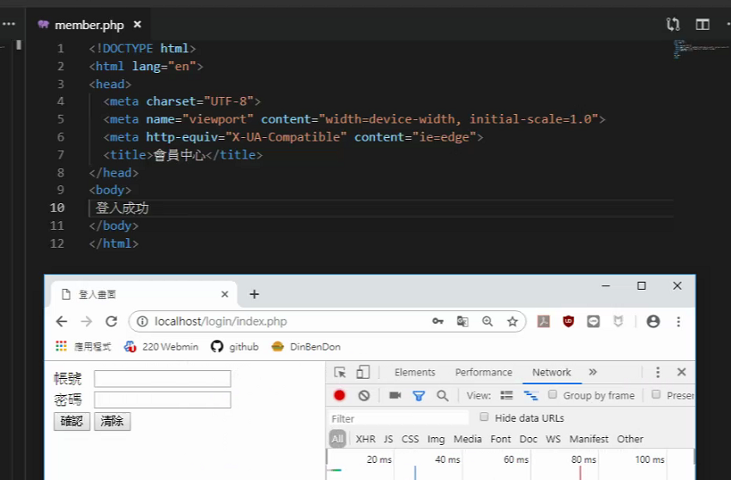

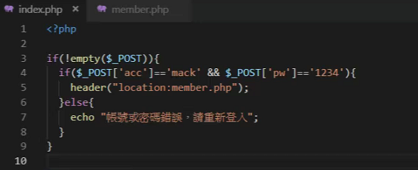

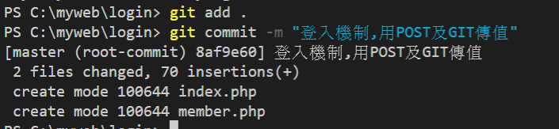

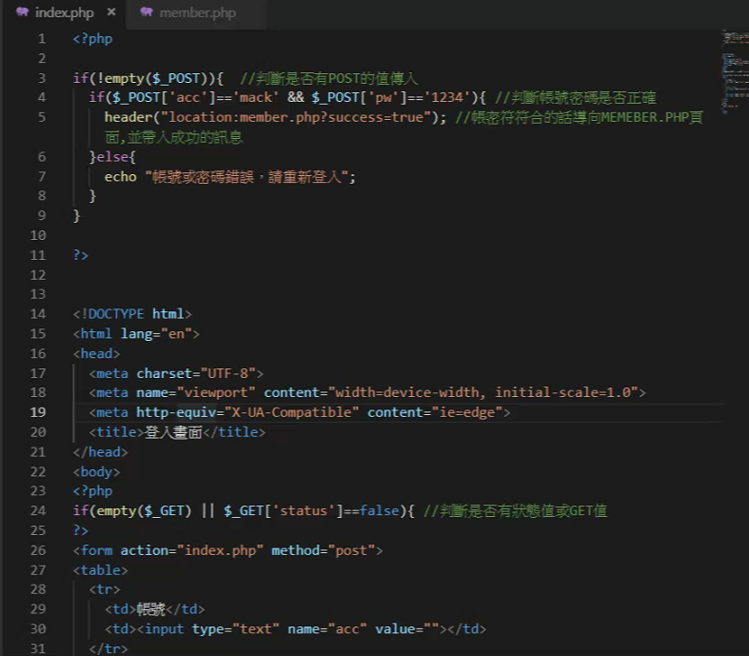

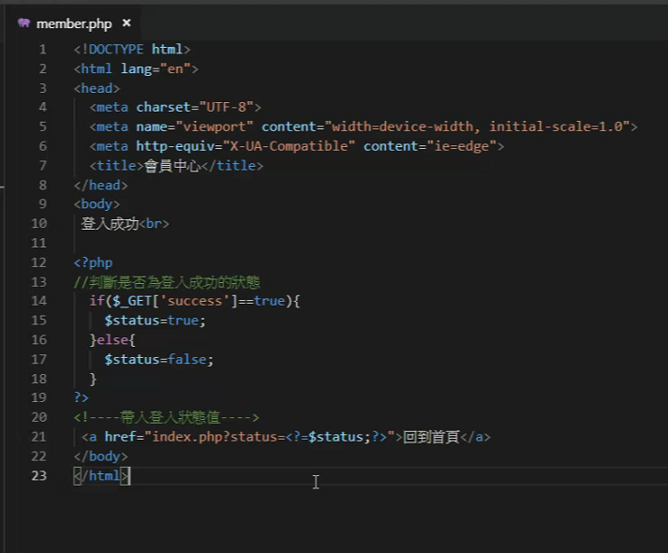

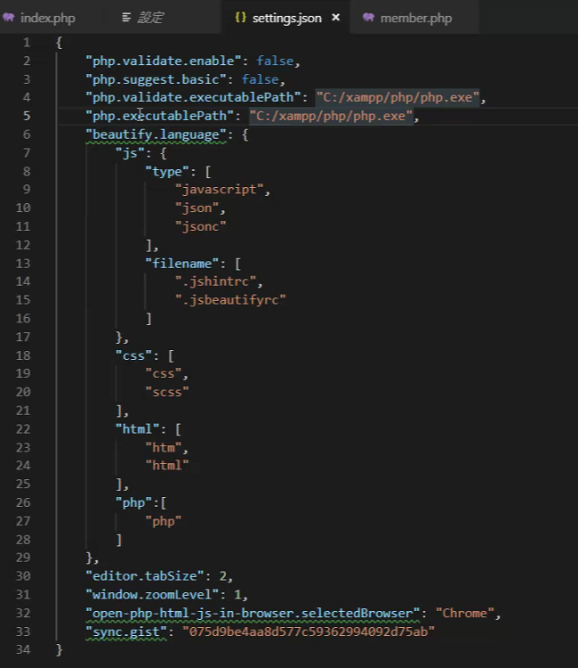

<?php

if($_GET['success']==true){

$status=true;

}else{

$status=false;

header("location:index.php");

exit();

}

?>

回之前版本

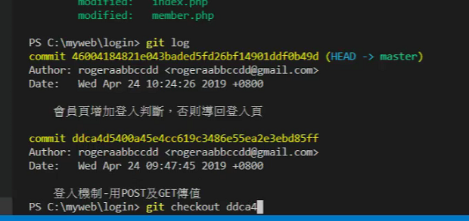

$_COOKIE

Index.php

<?php

if(!empty($_POST)){

if($_POST['acc']=='mack' && $_POST['pw']=='1234'){

setcookie("login","success",time()+300);

header("location:member.php");

}else{

echo "帳號或密碼錯誤,請重新輸入";

}

}

?>

<!DOCTYPE html>

<html lang="en">

<head>

<meta charset="UTF-8">

<meta name="viewport" content="width=device-width, initial-scale=1.0">

<meta http-equiv="X-UA-Compatible" content="ie=edge">

<title>登入畫面</title>

</head>

<body>

<!-- table>tr*3>td*2 -->

<?php

if(empty($_COOKIE['login']) ){

?>

<form action="index.php" method="post">

<table>

<tr>

<td>帳號</td>

<td><input type= "text" name="acc" vale=""> </td>

</tr>

<tr>

<td>密碼</td>

<td><input type="password" name="pw" value=""> </td>

</tr>

<tr>

<td><input type="submit" value="確認"></td>

<td><input type="reset" value="清除"></td>

</tr>

</table>

</form>

<?php

}else{

echo "你已登入過";

echo "<a href='member.php'>回到會員中心</a>";

}

?>

</body>

</html>

Member.php

<?php

if(empty($_COOKIE['login'])){

header("location:index.php");

exit();

}

?>

<!DOCTYPE html>

<html lang="en">

<head>

<meta charset="UTF-8">

<meta name="viewport" content="width=device-width, initial-scale=1.0">

<meta http-equiv="X-UA-Compatible" content="ie=edge">

<title>會員中心</title>

</head>

<body>

登入成功

<a href="index.php">回到首頁 </a>

</body>

</html>

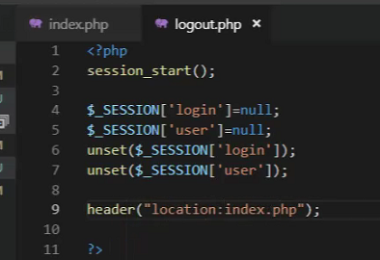

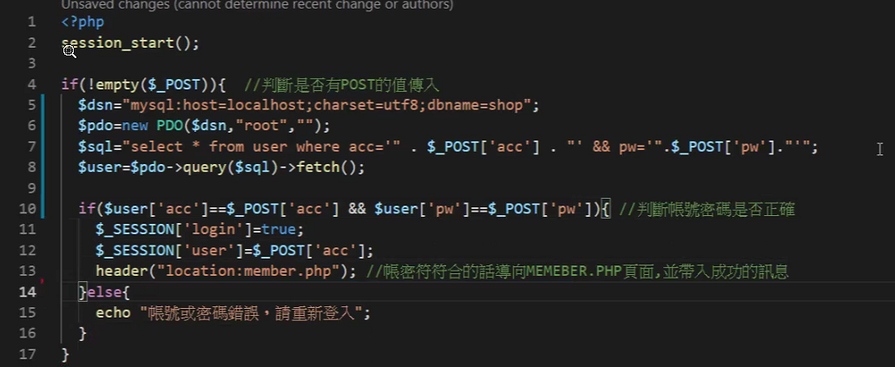

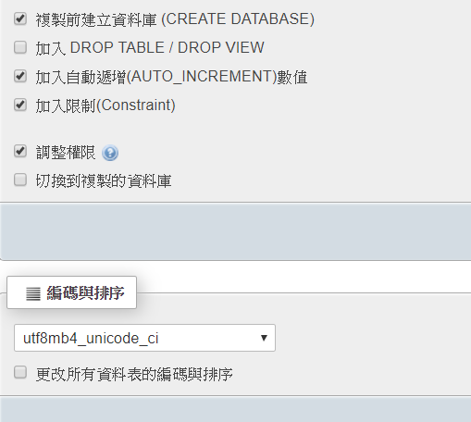



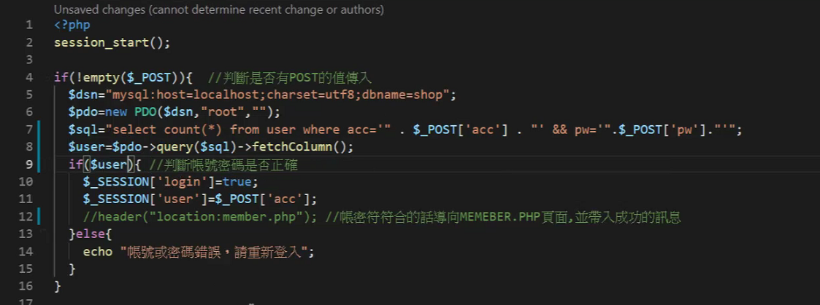

<?php

session_start();

if(!empty($_POST)){ //判斷是否有POST的值傳入

$dsn="mysql:host=localhost;charset=utf8;dbname=shop";

$pdo=new PDO($dsn,"root","");

$sql="select * from user where acc='" .$_POST['acc']. "' && pw='".$_POST['pw']."'";

$user=$pdo->query($sql)->fetchColumn();

echo $user['acc'];

echo "-";

echo $user['pw'];

if($user){ //判斷帳號密碼是否正確

$_SESSION['login']=true;

$_SESSION['user']=$_POST['acc'];

//header("location:member.php"); //帳密符合的話導入location,導入成功訊息

}else{

echo "帳號或密碼錯誤,請重新輸入";

}

}

?>

